20521824_Phạm Hà Minh Quyên_LAB2

<https://github.com/MinhQuyennn/lab2>

**Basic Javascript – Exercise 2 (DOM)**

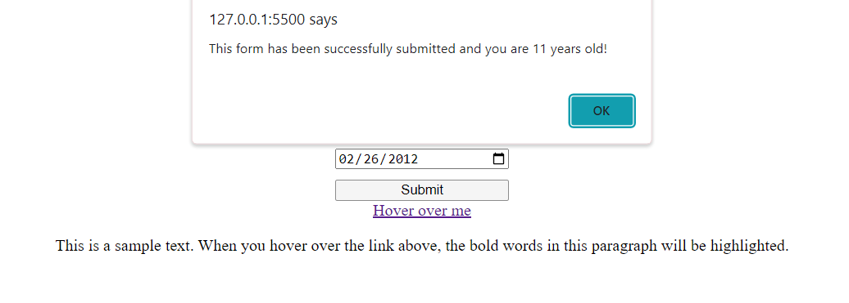

**Exercise 3**

**CANVAS**

**DOM**

**Javascript – Homework**

**Javascript – Homework 2.1 (Option 1)**

**Javascript – Homework 2.2**

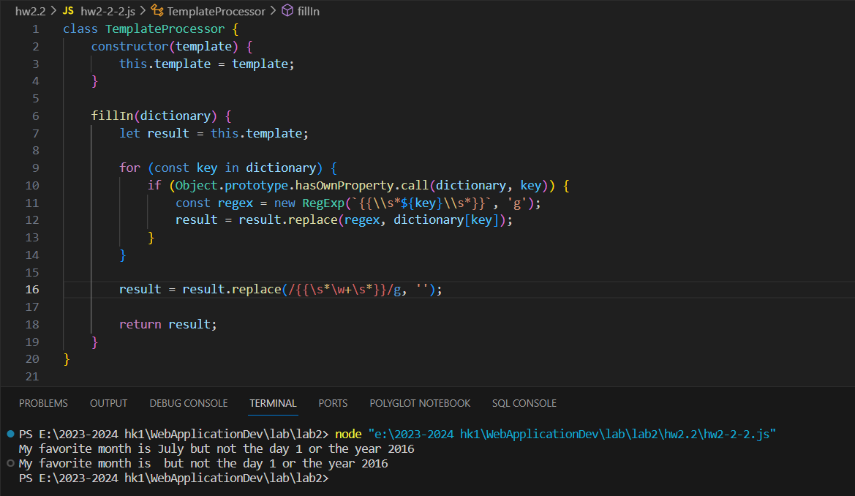

**Javascript – Homework 2.3**

**PART1: CALCULATOR**

**PART2: COUNT DOWN**

